JHU ECON 602:
MACROECONOMIC THEORY AND POLICY (Fall 2022)

Practice Questions for Part C Quiz

- True, False or Uncertain:

- The increase in output in the United States since 1890 is simply the result of the large increase in U.S. population from 63 million to more than 320 million over this period.

- When comparing the standard of living across countries, we use purchasing power parity (PPP) numbers, which adjust the income numbers for the purchasing power of different countries.

- Among the OECD, countries with lower levels of output per person in 1950 have typically grown slower in subsequent years.

- Among a broad group of countries, there is a strong negative relationship between the growth rate of output since 1960 and the level of output per person in 1960.

- The production function shows the relationship between production and economic policies.

- Economists assume that increases in capital per worker lead to smaller and smaller increases in output per worker.

- An improvement in technology shifts the production function up, leading to an increase in income per capita for a given level of capital per worker.

- In the Solow growth model, a lower saving rate does not permanently affect the growth rate of income, but it does raise the level of income.

- Since 1970, the savings ratio in Japan has been nearly 30% but the U.S. saving ratio is close to zero because the United States encourages excessive consumption.

- According to the production function, higher capital per worker leads to higher output per worker.

- If investment per worker exceeds depreciation per worker, the change in capital per worker is positive and the capital stock increases.

- In the Solow model, the state in which income per worker and capital per worker are no longer changing is called the steady state of the economy.

- In the Solow model, an increase in the saving rate will lead to higher per capita incomes for some time, but not once the economy reaches the steady state.

- There is a strong positive relation between the degree of protection from expropriation and the level of GDP per person, highlighting the importance of the protection of property rights.

- The large improvements in the standard of living in advanced countries since 1950 have come with stagnant employment and a trend increase in the unemployment rate.

- Get the Picture

- What does this picture show?

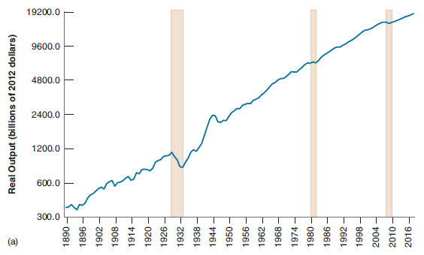
- What is this relationship called and what can lead to an upward shift in the relationship?

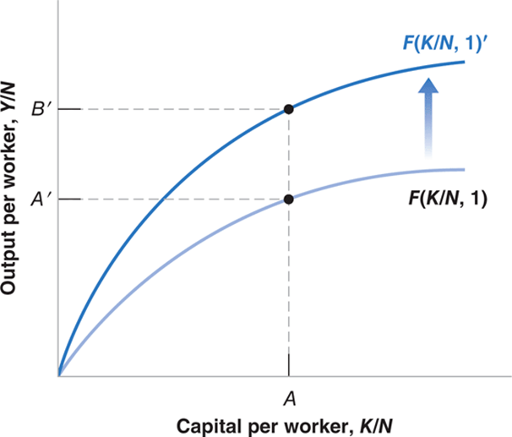

- Explain why in the Solow model the economy converges to the steady-state capital per worker ratio.

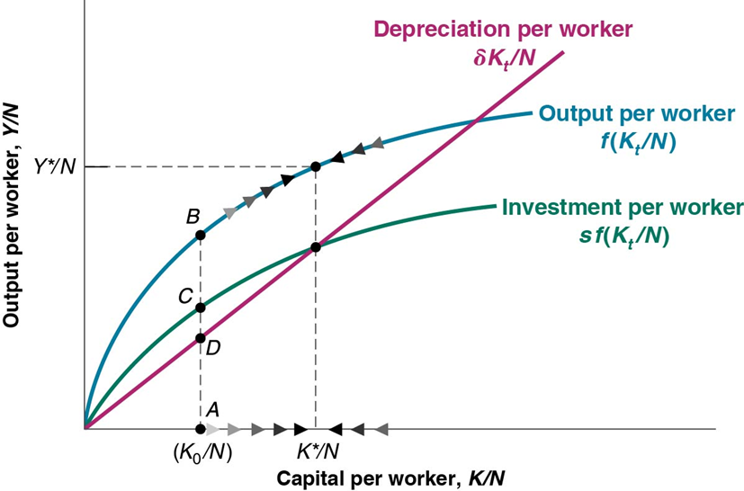

- What does this picture show?

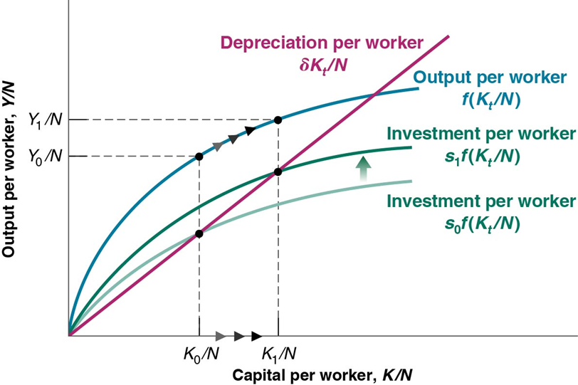

- What factor can explain the developments shown in this picture?

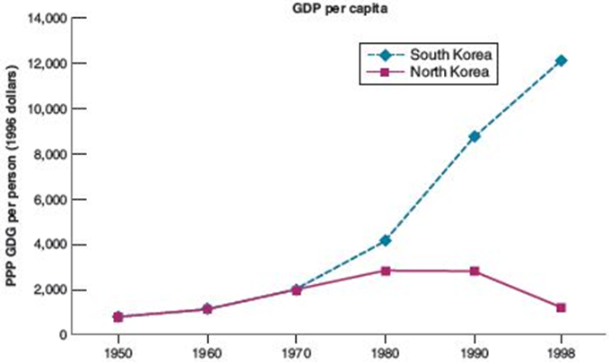

- What does this picture show?

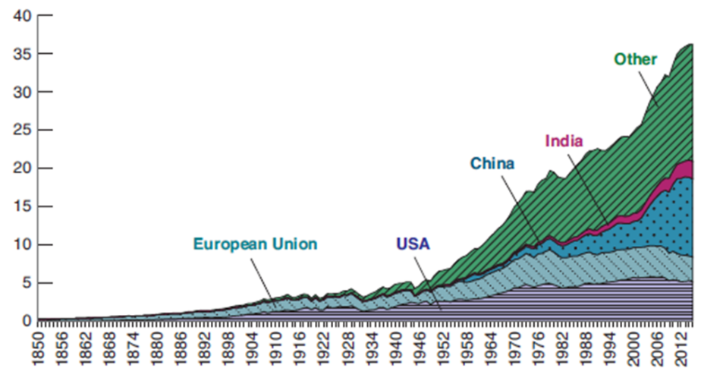

- What does this picture show?

