JHU ECON 602:
MACROECONOMIC THEORY AND POLICY (Fall 2022)

Answers to Practice Questions for Part C Quiz

- True, False or Uncertain:

- The increase in output in the United States since 1890 is simply the result of the large increase in U.S. population from 63 million to more than 320 million over this period.

False. The increase in output is not simply the result of the increase in population because output per person has risen by a factor of 10.

- When comparing the standard of living across countries, we use purchasing power parity (PPP) numbers, which adjust the income numbers for the purchasing power of different countries.

True.

- Among the OECD, countries with lower levels of output per person in 1950 have typically grown slower in subsequent years.

False. Among the OECD, countries with lower levels of output per person in 1950 have typically grown faster in subsequent years.

- Among a broad group of countries, there is a strong negative relationship between the growth rate of output since 1960 and the level of output per person in 1960.

False. Among a broad group of countries, there is no clear relationship between the growth rate of output since 1960 and the level of output per person in 1960.

- The production function shows the relationship between production and economic policies.

False. The production function shows the relationship between production, inputs and technology.

- Economists assume that increases in capital per worker lead to smaller and smaller increases in output per worker.

True.

- An improvement in technology shifts the production function up, leading to an increase in income per capita for a given level of capital per worker.
True.

- In the Solow growth model, a lower saving rate does not permanently affect the growth rate of income, but it does raise the level of income.

False. In the Solow growth model, a higher saving rate does not permanently affect the growth rate of income, but it does raise the level of income.

- Since 1970, the savings ratio in Japan has been nearly 30% but the U.S. saving ratio is close to zero because the United States encourages excessive consumption.

False. Since 1970, the savings ratio in Japan has been nearly 30% but the U.S. saving ratio is below 20%.

- According to the production function, higher capital per worker leads to higher output per worker.

True.

- If investment per worker exceeds depreciation per worker, the change in capital per worker is positive and the capital stock increases.

True.

- In the Solow model, the state in which income per worker and capital per worker are no longer changing is called the steady state of the economy.

True.

- In the Solow model, an increase in the saving rate will lead to higher per capita incomes for some time, but not once the economy reaches the steady state.

True.

- There is a strong positive relation between the degree of protection from expropriation and the level of GDP per person, highlighting the importance of the protection of property rights.

True.

- The large improvements in the standard of living in advanced countries since 1950 have come with stagnant employment and a trend increase in the unemployment rate.

False. The large improvements in the standard of living in advanced countries since 1950 have come with rising employment and no trend increase in the unemployment rate.

- Get the Picture

- What does this picture show?
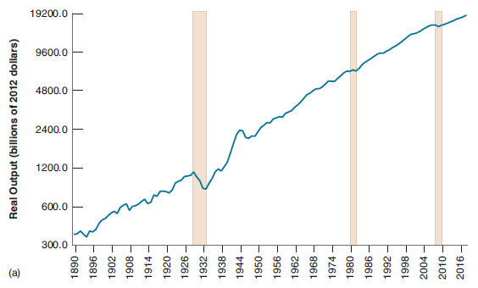

US Real GDP
- What is this relationship called and what can lead to an upward shift in the relationship?

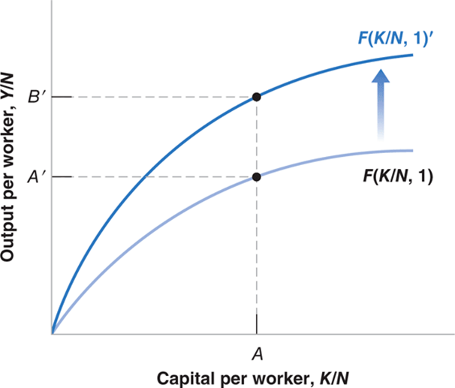

The production function. An increase in technology (efficiency) can lead to an upward shift.

- Explain why in the Solow model the economy converges to the steady-state capital per worker ratio.

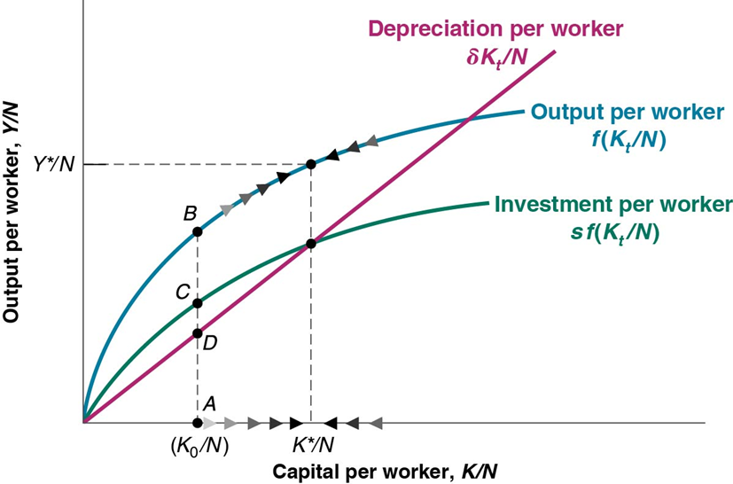

If investment per worker if greater than depreciation per worker, the capital stock per worker increases until the economy reaches the steady state capital per worker (K*/N). If investment per worker if lower than depreciation per worker, the capital stock per worker falls until the economy reaches the steady state capital per worker (K*/N).

- What does this picture show?

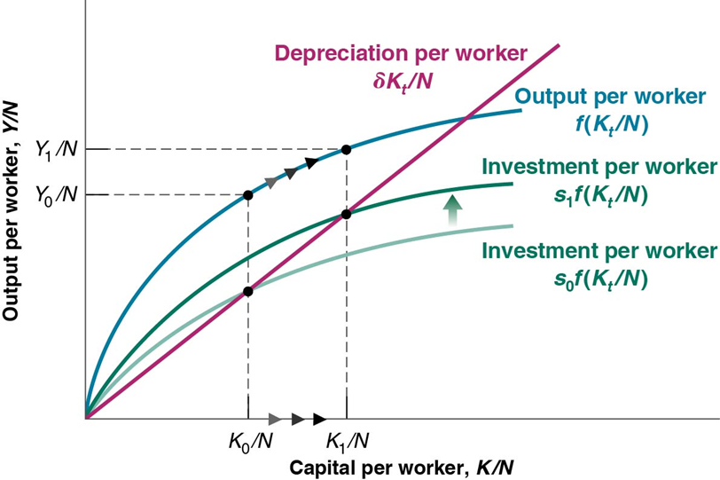

An increase is the economy’s savings rate from s_{o} to s₁ raises the steady state level of income.
- What factor can explain the developments shown in this picture?

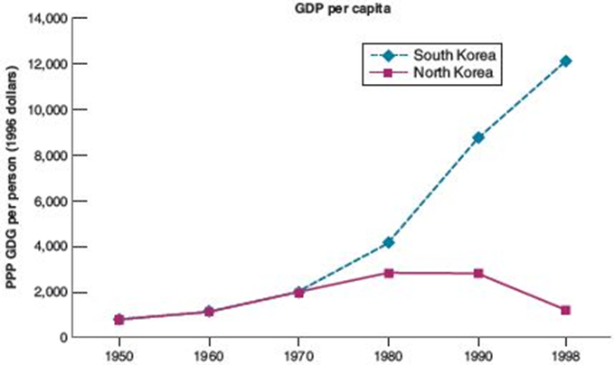

Private ownership and protections of property rights can explain why South Korea’s income outstripped that of North Korea.

- What does this picture show?

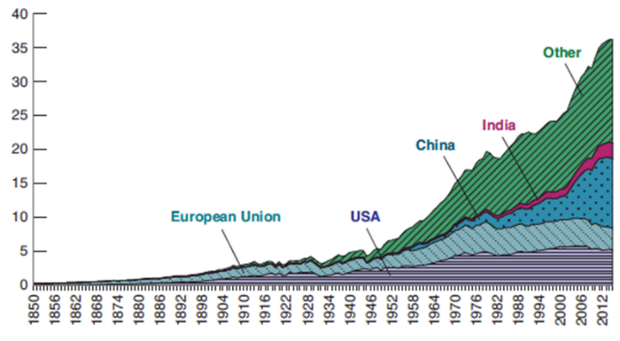

CO₂ emissions.

- What does this picture show?

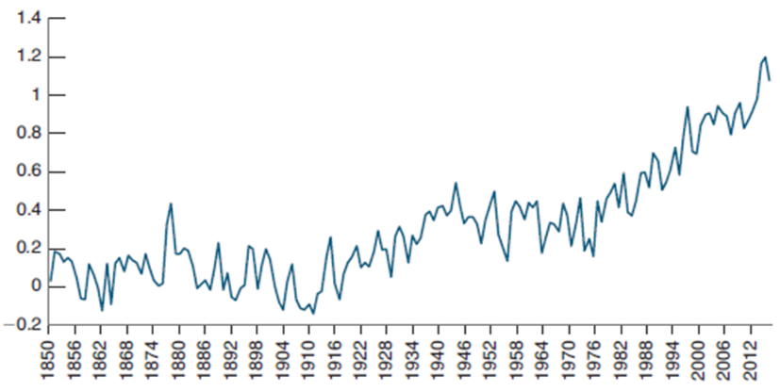

Global average temperature (difference from 1960-90 average).

