JHU ECON 602
MACROECONOMIC THEORY AND POLICY (Fall 2022)

Practice Quiz 2 for Part B
- True, False or Uncertain. State whether the following statements are True, False or Uncertain. For statements that are False, correct the error or errors by writing out the full correct statement. (Note that there may be more than one error and for full credit you have to correct all of them). For statements that are Uncertain, explain why that is the case.

- In the open economy IS-LM model, an increase in government spending leads to an increase in output. If the central bank keeps the exchange rate unchanged, the inflation rate also remains unchanged.

- When expectations are incorporated in the IS-LM model, the IS curve becomes flat, which in turn leads to the flattening of the Phillips Curve.

- In the open economy IS-LM model, a decrease in domestic demand leads to an increase in domestic output and a deterioration of the trade balance.

- In the IS/LM model, an increase in the risk premium leads to a shift of the LM curve to the left and an increase in equilibrium output.

- In the IS/LM model, equilibrium in the goods market implies that an increase in the interest rate leads to a decrease in output.

- In the IS-LM model, when account is taken of its effect on expectations, an increase in government spending need not lead to a decrease in output.

- Exports are positively related to domestic income and negatively to the inflation rate.

- Wholesale funding is a process in which banks rely on borrowing from the Fed through open market operations to finance the purchase of their assets.

- Macroeconomists believe that, in the medium run, real GDP increases over time due to the easing of monetary policy.

- The National Bureau of Economic Research concluded that the U.S. economy was in a recession between March 2001 and December 2001, triggered by sharp increases in investment, which crowded out consumption.

- In the IS/LM model, a decrease in taxes shifts the LM curve down. This leads to a decrease in the equilibrium level of output.

- To counter the recession of 2001, the U.S. government raised interest rates, cut spending and raised tax rates.

- Macroeconomists believe that in the medium run monetary policy determines what people really care about such as the inflation rate and the trend rate of real GDP.

- In the IS/LM model, a monetary expansion shifts the LM curve down, and leads to higher output.

- In the IS/LM model, a decrease in the inflation rate shifts the LM curve up, and leads to lower output.

- In the IS/LM model, a fiscal expansion shifts the IS curve to the left and a monetary expansion shifts the LM curve up. Both lead to lower output.

- The fact that fiscal policy does not affect real variables in the short run is referred to as the neutrality of money.

- In the United States, from 2006 on, many home mortgages went underwater because of declines in policy interest rates.

- In the United States, the effects of an increase in the oil price are to raise output and lower the price level.

- Movements in output around its trend are called output fluctuations (business cycles)

- The interest parity condition states that an increase in the domestic interest rate leads to an increase in the exchange rate.

- In the open-economy IS-LM model, an increase in the interest rate reduces output both directly and indirectly through the interest rate.

- Imports are positively related to domestic income and negatively to the exchange rate.

- In the open-economy IS model, a higher domestic interest rate leads to a higher exchange rate (an appreciation).

- Get the Picture

- What are examples of some policies or shocks which can lead to a leftward shift in the IS curve?

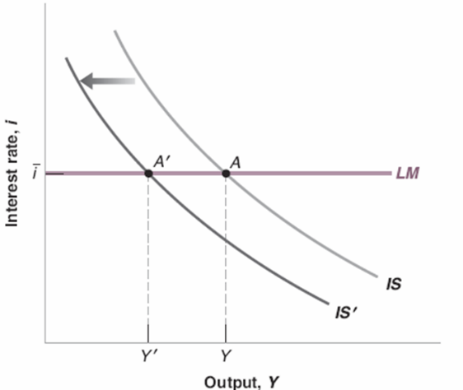

- What would be the effects in the figures below if there is an increase in government spending?

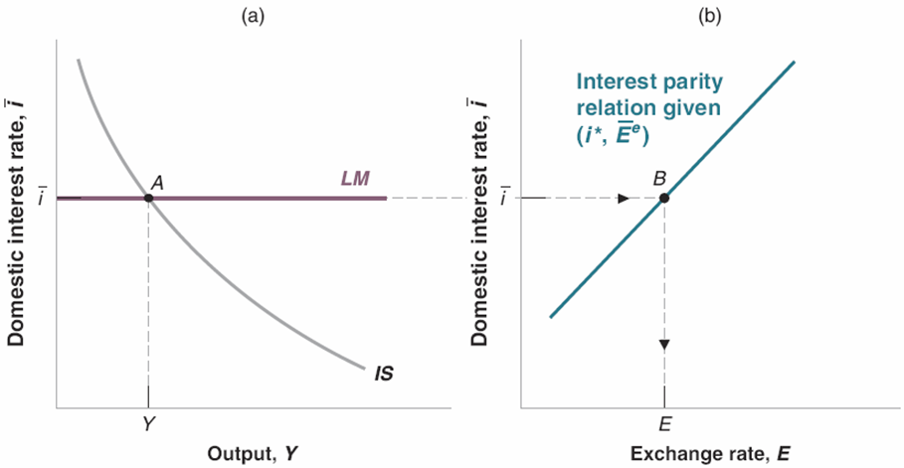

- The picture below depicts the effects of the Great Recession (or Global Financial Crisis) in the United States. Explain what the shifts in the curves are showing.

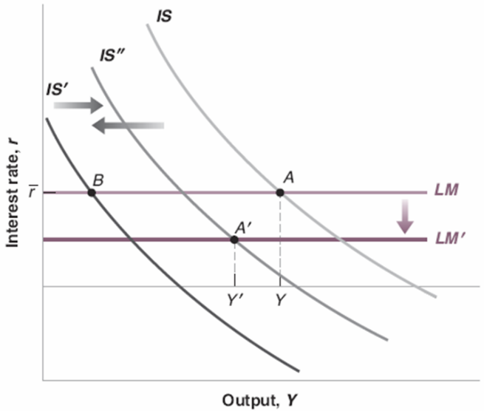

- Which U.S. macroeconomic variable does the graph below show? (i) U.S. inflation rate; (ii) U.S. exchange rate; (iii) U.S. house prices; (iv) none of the above.

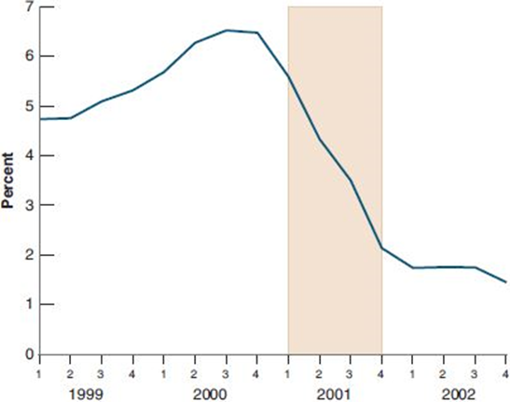

- What factors led to the decline in U.S. consumer confidence shown in this picture?
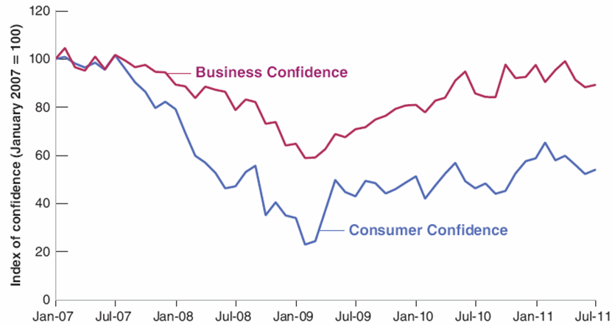

- The current account in Greece improved after 2007. What factors brought about this improvement?

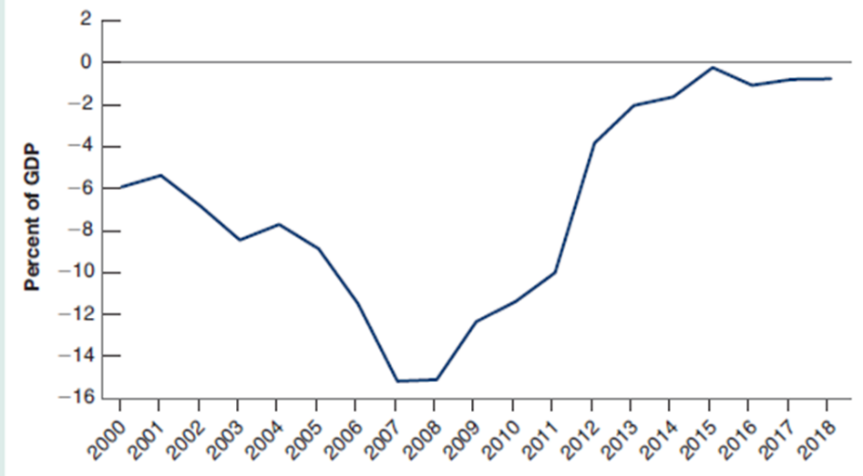

- What does the picture below depict?
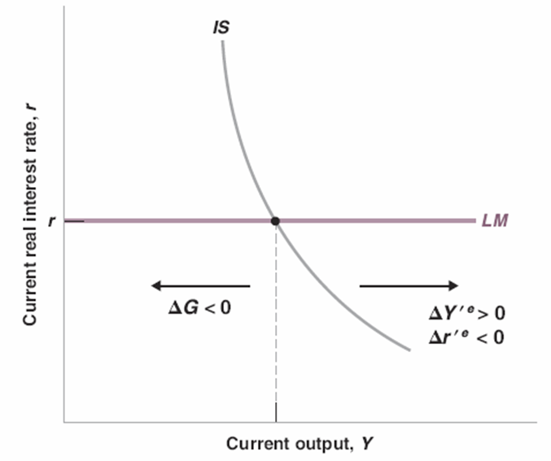

- What is the most interesting thing you have learnt in this part of the course (Part B)?

