JHU Econ 602 (Exam 2) – Answers (or sketch of answers)
NAME: ________________________________

- Multiple Choice: Circle the correct answer (30 points; 3 points each)

- In the IS/LM model, equilibrium in the goods market implies that:

- an increase in the interest rate leads to a decrease in output.
- an increase in the interest rate leads to an increase in output, because the LM curve is flat.
- an increase in the interest rate leads to an increase in inflation, because of Taylor’s Rule.
- both a and c.

- In the IS/LM model, an increase in taxes:
- shifts the LM curve down, leading to a decrease in the equilibrium level of output.
- shifts the IS curve to the right, leading to a decrease in the equilibrium level of output.
- shifts the IS curve to the left, leading to a decrease in the equilibrium level of output.
- none of the above.

- In the IS/LM model, a monetary expansion:
- shifts the LM curve down and leads to higher output.
- shifts the IS curve to the right and leads to higher output.
- both a and b, but only if the central bank raises the policy interest rate.
- none of the above.

- In the IS/LM model:
- a fiscal expansion shifts the IS curve to the right and a decrease in policy interest rates by the central bank shifts the LM curve down. Both lead to higher output.
- a fiscal expansion shifts the IS curve to the right and a monetary expansion shifts the LM curve down. Both lead to higher output.
- a fiscal expansion shifts the IS curve to the right and a decrease in policy interest rates by the central bank shifts the LM curve up. This keep output unchanged.
- both a and b.

- In the open economy IS-LM model, an increase in government spending:
- leads to an increase in output. If the central bank keeps the exchange rate unchanged, the interest rate also remains unchanged.
- leads to an increase in output. If the central bank keeps the interest rate unchanged, the inflation rate also remains unchanged.
- leads to a decrease in output. If the central bank keeps the interest rate unchanged, the exchange rate also remains unchanged.
- none of the above.

- In the open economy IS-LM model, a decrease in domestic demand: (Question dropped)
- leads to an increase in domestic output and a deterioration of the trade balance.
- leads to an increase in inflation and a deterioration of the trade balance.
- leads to an increase in domestic output and an improvement in the trade balance.
- both a and b.

- Imports are:
- positively related to domestic income and negatively to the inflation rate.
- positively related to domestic income and negatively to the real exchange rate.
- positively related to foreign income and negatively to the inflation rate.
- none of the above.

- Movements in output around its trend are called:
- output fluctuations (business cycles)
- output fluctuations (Okun’s Law)
- productivity growth
- output fluctuations (Taylor’s Rule)

- The interest rate parity condition states that:
- an increase in the exchange rate leads to an increase in the interest rate.
- an increase in the exchange rate leads to an increase in the inflation rate.
- an increase in the interest rate leads to an increase in the exchange rate.
- an increase in the interest rate leads to a decline in the inflation rate.

- Movements in output around its trend are called:
- output fluctuations (business cycles)
- output fluctuations (Okun’s Law)
- productivity growth
- output fluctuations (Taylor’s Rule)

II. Draw the Picture (20 points; 5 points each)
- Use the IS/LM model to show the impact of the U.S. recession of 2001 and the steps taken by the central bank and the government in response to the recession. Label your chart clearly (explain each shift in the curve clearly; label the y-axis and x-axis clearly).
--- Initial shock due to 9/11. IS shifts in.
--- Govt. tries to shift IS back with government spending and tax cuts
--- Fed cuts interest rates to 2 percent, shifting LM down

- Use the IS/LM model to show the impact of the U.S. recession of 2001 and the steps taken by the central bank and the government in response to the recession. Label your chart clearly (explain each shift in the curve clearly; label the y-axis and x-axis clearly).
(Same as above)

- Show the impact of an increase in government spending in the IS/LM model. How would your answer (and your picture) change if account is taken of expectations? (Label both charts clearly).
--- in standard (static) IS/LM model, shift IS to the right.
--- In model with expectations, output may not increase (if private investment and consumption decline because people worry about economy’s future prospects, e.g. if increased government spending leads to worries about government’s ability to repay the debt). Interest rates may also increase because of worries about government debt, dampening private investment and consumption.
- Draw a picture of Okun’s Law. Illustrate how a picture of Okun’s Law for Spain would look compared to a picture of Okun’s Law for Japan.
--- Relationship between output growth and change in unemployment rate.
--- Stronger relationship between the two in Spain than in Japan.
(Note: you may have lost between 1 and 3 points if you did not label the axes correctly or you did show clearly a stronger relationship for Spain than for Japan)

- Short Answers (30 points; 3 points each for first six; 6 points for the last two):

- What are fiscal policies? What is a fiscal contraction?
--- fiscal policies: government’s tax and spending policies
--- fiscal contraction: increase in government deficit

- What is monetary policy? What is a monetary expansion?
--- monetary policy: central bank policies on interest rates (money supply)
--- monetary expansion: lowering of interest rates or increase in money supply

- What are ‘animal spirits’? What is the relationship between animal spirits and changes in the risk premium?

--- animal spirits: swings in private sector confidence
--- when animal spirits are high, risk premium is low

- What is the federal funds rate? What are the effects of an increase in the federal funds rate?
--- fed funds rate is the interest rate at which banks borrow and lend finds to one another overnight (very short term)
--- the Fed (US central bank) is able to target the fed funds rate in the short term
--- when the Fed targets a higher fed funds rate, the LM shifts up to the left and output contracts. Also inflation come down.

- What is the neutrality of money?
--- The property that increases in the money supply (declines in target interest rates) do not affect real variables like real GDP in the medium and long run, but only affect nominal variables like inflation and nominal interest rates.

- How would you summarize what you learned in Part B of the course?
--- you tell me!
- (6 points) The picture below shows what has happened to global house prices since 1870.
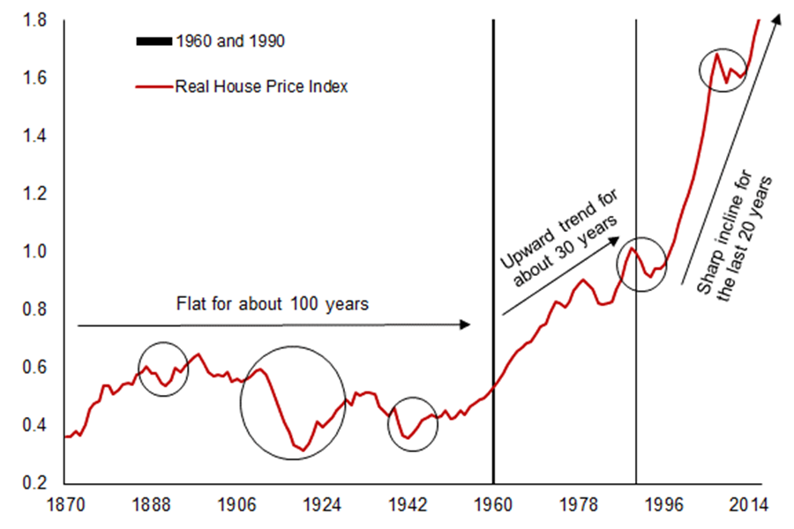
Note: The index is a simple average of real house prices for Australia, Belgium, Canada, Denmark, Finland, France, Germany, Japan, Netherlands, Norway, Sweden, Switzerland, United Kingdom, and United States.
How would you use the housing demand and housing supply framework discussed in class to explain the movements in this chart (particularly why house prices went from being ‘flat’ to having an ‘upward trend’ and then a ‘sharp incline’)? Feel free to use charts to illustrate your answer.

--- In first period, 1870 and 1960, demand expanded due to income and population growth, but supply also expanded as land was still plentiful. So demand and supply both expanded, keeping house prices in check.
--- In second period, 1960 to 1995, demand continued to expand due to income and population growth and was also boosted by availability of credit (mortgage finance). At the same time, supply was not as plentiful. With demand outstripping supply, house prices went up.
--- In the third period, 1995 onwards, demand grew for all the factors mentioned above, but zoning regulations constrained supply further, leading to a steep incline in house prices.
Note: you may have lost between 1 and 4 points depending on the quality of your answer (e.g. if you did not mention credit availability or zoning regulations).
- (6 points total; 2 points each)

- What is the impossible trinity?
--- Countries have to choose among independent monetary policy, stability in exchange rates and free flow of capital.

- Explain why (mainland) China has to choose two of the three goals shown in the trinity?
--- Suppose central bank cut interest rates in face of a slowing economy
--- Lower interest rate will lead to foreign capital leaving (if country chooses to have free movement of capital) or depreciation of the currency (so risking instability in exchange rate)
--- So central bank has to choose one of the two goals.

- On what side of the triangle would you place Germany? On what side of the triangle would you place the European Central Bank?

--- ECB is like US Fed (independent monetary policy and free capital flow)

--- Germany is like HK (free capital flow and stable exchange rate – it is as if the German mark has to maintain a fixed exchange rate versus the euro).

