JHU ECON 602:
MACROECONOMIC THEORY AND POLICY
(Fall 2022)

Answers to Practice Quiz 1 for Part B Exam

- True, False or Uncertain:

- In the IS/LM model, equilibrium in the goods market implies that an increase in the interest rate leads to a decrease in output.

True.

- In the IS/LM model, an increase in taxes shifts the LM curve down. This leads to a decrease in the equilibrium level of output.

False. In the IS/LM model, an increase in taxes shifts the IS curve to the left. This leads to a decrease in the equilibrium level of output.

- In the IS/LM model, a monetary expansion shifts the LM curve down, and leads to higher output.

True.

- In the IS/LM model, a decrease in the policy interest rate by the central bank shifts the LM curve up, and leads to lower output.

False. In the IS/LM model, a decrease in the policy interest rate by the central bank shifts the LM curve down, and leads to higher output.

- In the IS/LM model, a fiscal expansion shifts the IS curve to the left and a monetary expansion shifts the LM curve up. Both lead to lower output.

False. In the IS/LM model, a fiscal expansion shifts the IS curve to the right and a monetary expansion shifts the LM curve down. Both lead to higher output.

- The National Bureau of Economic Research concluded that the U.S. economy was in a recession between March 2001 and December 2001, triggered by sharp declines in investment demand.

True.

- During the recession of 2001, the Federal Reserve cut the federal funds rate from 6.5% in January to the zero lower bound at the end of 2001.

False. The Federal Reserve cut the federal funds rate from 6.5% in January to 2% at the end of 2001.

- During the 2001 recession, the U.S. government cut taxes and increased government spending.

True.

- In the IS/LM model, an increase in the risk premium leads to a shift of the IS curve to the left and a decrease in equilibrium output.

True.

- In the United States, from 2006 on, many home mortgages went underwater because of the flooding caused by climate change.

False. In the United States, from 2006 on, many home mortgages went underwater because the declines in house price meant that the value of the mortgage exceeded the value of the house.

- Securitization is the creation of securities based on a bundle of assets, such as mortgage-based securities.

True.

- Wholesale funding is a process in which banks rely on borrowing from other banks or investors to finance the purchase of their assets.

True.

- Macroeconomists believe that in the medium run, real variables (such as real GDP) are independent of monetary policy.

True.

- Macroeconomists believe that in the medium run monetary policy determines the rate of inflation and the nominal rate of interest but not real variables such as real GDP and the real interest rate.

True.

- The fact that monetary policy does not affect nominal variables in the short run is referred to as the neutrality of money.

False. The fact that monetary policy does not affect real variables in the medium run is referred to as the neutrality of money.

- In the United States, the effects of an increase in the price of oil on output and the price level are smaller than they used to be.

True.

- Movements in output around its trend are called output fluctuations (business cycles)

True.

- When expectations are incorporated in the IS-LM model, the IS curve becomes steeply downward sloping. This means that, other things being equal, a change in the current interest rate has a small effect on output.

True.

- In the IS-LM model, when account is taken of its effect on expectations, the decrease in government spending need not lead to a decrease in output.

True.

- Imports are positively related to domestic income and negatively to the real exchange rate.

False. Imports are positively related to domestic income and the real exchange rate.

- In the open economy IS-LM model, an increase in domestic demand leads to an increase in domestic output but leads also to a deterioration of the trade balance.

True.

- An increase in investment must be reflected in either an increase in private saving or a decline in public saving, or in an improvement of the current account balance.

False. An increase in investment must be reflected in either an increase in private saving or public saving, or in a deterioration of the current account balance.
- The interest parity condition states that an increase in the domestic interest rate leads to an increase in the exchange rate.

True.

- In the open-economy IS-LM model, an increase in the interest rate reduces output both directly and indirectly through the inflation rate.

False. In the open-economy IS-LM model, an increase in the interest rate reduces output both directly and indirectly through the exchange rate.

- In the open economy IS-LM model, an increase in government spending leads to an increase in output. If the central bank keeps the interest rate unchanged, the exchange rate also remains unchanged.

True.

- Get the Picture

- The picture below depicted the Great Recession (or Global Financial Crisis) in the United States. Explain what the shifts in the curve are showing.

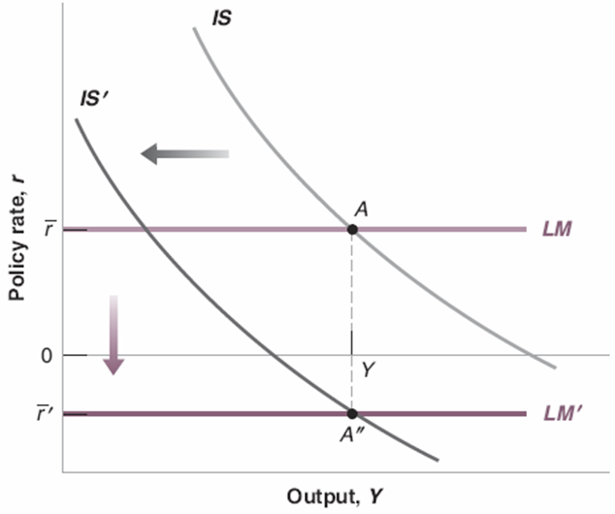

The IS curve shifted to the left due to an increase in the risk premium caused by the financial crisis. Monetary policy (the Fed) responded by cutting policy interest rates, shifting the LM curve down, but could not push interest rates below the zero lower bound.

- Which U.S. macroeconomic variable does the graph below show? (i) U.S. inflation rate; (ii) U.S. exchange rate; (iii) U.S. house prices.

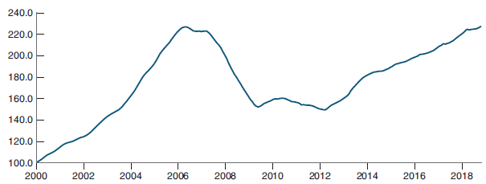

This picture shows U.S. house prices; this is evident from the collapse in the series around 2006.

- What factors led to the decline in U.S. consumer confidence shown in this picture?
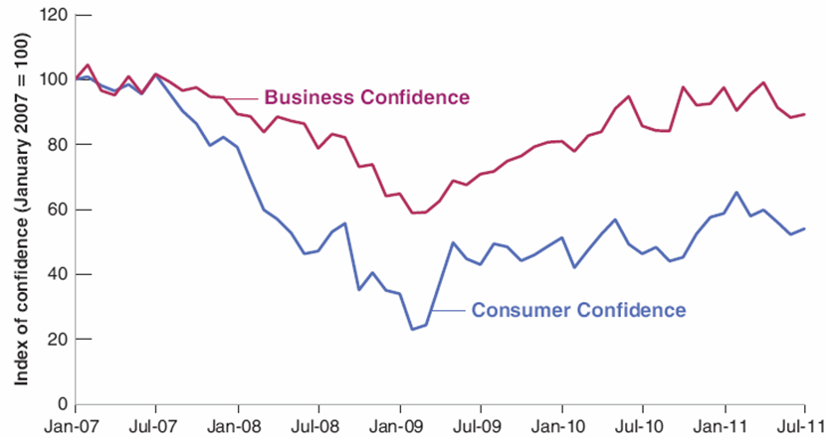

The collapse in U.S. house prices in 2006 triggered a financial crisis which led to a drop in confidence.

- What is the name of the concept represented by the chart below? Explain why countries have to choose two sides of the triangle.

The concept is called The Impossible Trinity.
We can explain why countries have to choose two sides through counterfactual arguments to show why they cannot have all three.

For example in HK’s case:
- Suppose HKMA tries to cut interest rates (say in response to a recession).
- Then foreign capital will want to leave (because HK interest rates will become lower than foreign interest rates if HKMA cuts interest rates).
- The cut in rates will also put pressure on the peg with the US dollar.
- If HK wants to keep free capital mobility and maintain the peg, it cannot cut interest rates. Si it cannot have independent monetary policy.
One can make similar counterfactual arguments for China and the United States.

