NAME: ______PL_________

- Circle the right answer (3 points each; 1 point bonus if you get them all correct):

- The Taylor Rule states that if inflation increases above its target (holding the GDP gap constant),

- monetary policy should be eased by lowering the real policy interest rate.

- monetary policy should be tightened by raising the real policy interest rate.

- fiscal policy should be eased by lowering tax rates.

- fiscal policy should be tightened by raising tax rates.

- The Taylor Rule states that if real GDP falls below trend (while inflation is at the target range),

a. monetary policy should be eased by lowering the real policy interest rate.

b. monetary policy should be tightened by raising the real policy interest rate.

c. fiscal policy should be eased by lowering tax rates.

d. fiscal policy should be tightened by raising tax rates.

- Okun’s Law states that a cyclical reduction in income is associated with a cyclical increase in unemployment because:

- when the economy is doing poorly, companies tend to lay off people.

- when output falls, more people enter the labor force.

- when unemployment goes up, people have less incomes.

- when unemployment goes up, companies have less people to help them produce.

- Global average incomes have roughly tripled since 1960,

- but global average output has remained stagnant due to the decline of manufacturing.

- while global average output has quadrupled due to the growth of the financial sector.

- and global average output has also grown by roughly the same amount.

- but have remained stagnant in Africa.

- The provision of unemployment insurance raises the natural rate of unemployment by

- raising the job separation rate.

- raising the job finding rate.

- raising both the job separation and job finding rates.

- lowering both the job separation and job finding rates.

- If the real exchange rate rises, domestic goods become

- less expensive relative to foreign goods.

- more expensive relative to foreign goods.
- less expensive relative to foreign currency.

- more expensive relative to domestic currency.

- The U.S. nominal interest rate has declined considerably since the early 1980s,

- because expected inflation has risen substantially due to Fed actions.

- because real interest rates have risen due to the savings glut.

- because expected inflation has not changed much due to Fed actions.

- none of the above.

- The unemployment rate is

- the ratio of the number of people unemployed to the number of people in the labor force.

- the ratio of the number of people unemployed to the number of people employed.

- the ratio of the number of people unemployed to the population.

- the ratio of the number of people unemployed to the number of discouraged workers.

9. The U.S. civilian labor force:

a. is about half as large as its population.

b. is about a quarter as large as its population

c. is about twice as large as its population.

d. is equal to the population because everyone in the country works hard.

- The natural rate of unemployment in the United States

- is about 10 percent, but it generally falls to about 8 percent during a recession.

- is about 5 ½ to 6 percent

- tends to fall during recessions

- both (b) and (c).

11. Stabilization policy refers to policy actions aimed at
a. raising the trend rate of economic growth.
b. lowering the trend rate of unemployment.
c. both (a) and (b) above.
d. none of the above.

12. In the United States, real GDP has fluctuated over the course of the business cycle

- by between -1 percent and +1 percent.

- by between 4 percent and 8 percent.

- but not during the two most recent recessions due to prompt government actions.

- none of the above.

13. U.S. income per capita is about:

- $62,500, which is 25% of the world average.
- $62,500, but output per capita is much lower (about $30,000).
- $62,500, but output per capita is much higher (about $90,000).
- none of the above.
II. Complete the sentence (2 points each; 1 point bonus for excellent answers):

- In the United States, expectations of inflation became re-anchored in the mid-1990s because …

… the central bank was able to keep inflation low and stable over this period.

- The expected present discounted value of a sequence of future payments is …

… is the value today of this expected sequence of payments.

- Economists say that since 1960, the United States has become a much more open economy because …

… exports and imports have increased in relation to GDP.

- Tradable goods are goods that …
… compete with foreign goods in either domestic markets or foreign markets.

- According to economists, a real appreciation is …
… an increase in the real exchange rate, i.e., an increase in the relative price of domestic goods in terms of foreign goods.

- The interest parity condition states that …

… with free flow of capital, domestic and foreign interest rates should be equalized, except for expected depreciation.

- The ratio of exports to GDP can exceed one because …

… exports and imports may include exports and imports of intermediate goods.

III. Short Answers (4 points each):

- Describe the relationship between incomes and unemployment in the long run.

In general, there is no relationship because incomes trend upwards, while unemployment does not (it returns to a constant long-run average).

- What factors influence the evolution of the debt-to-GDP ratio?

The interest rate, the growth rate of the economy, the initial debt-to-GDP ratio and the primary fiscal balance.

- What is the yield curve? What is the normal slope of the yield curve and why?

Relationship between interest rates at different maturities. Normally, upward sloping, due to higher inflation expectations over longer-term.

- On what factors do consumption and investment depend, and why?

Consumption depends on current income and expected future income. Consumers like to smooth consumption, so they base decisions not only on current income but on wealth.

Investment depends on current profits (relative to user cost) and expected future profits. Like consumers, companies base decisions on current and future profits to avoid excessive dependence of investment decisions on current cash flow.

- What is the most interesting thing you have learnt in this course so far and why?

You told me, thanks.

- Get the Picture
- (2 points) Which variable does the chart below show? (i) the U.S. real exchange rate (ii) European unemployment rate; (iii) cyclical component of U.S. real GDP (iv) none of the above.
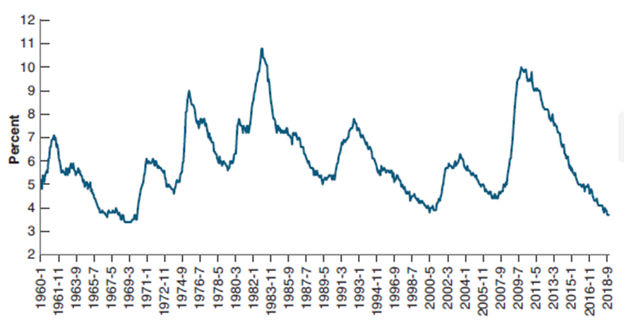

- (2 points) What is this chart called? Accelerationist Phillips Curve

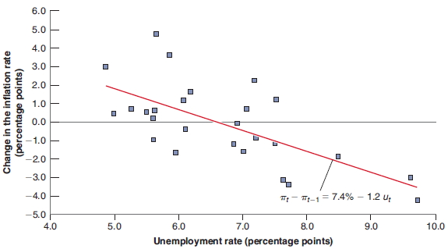
- (1 point) What is this chart called? Phillips Curve

