JHU ECON 602
MACROECONOMIC THEORY AND POLICY
(Fall 2022)

Group Assignment 1 (50 points)

Due by email (ploungani@imf.org) by 11 am on Tuesday, Sep. 20.
- (5 points): On January 27, 2022, U.S. President Biden said: “The GDP numbers for my first year show that we are finally building an American economy for the 21st Century, with the fastest economic growth in nearly four decades … And, for the first time in 20 years, our economy grew faster than China’s. This is no accident. My economic strategy is creating good jobs for Americans, rebuilding our manufacturing, and strengthening our supply chains here at home to help make our companies more competitive”. Do you agree with President Biden’s claim that the fast GDP growth in his first year (i.e., in 2021) is due to his economic strategy? Why or why not? https://www.whitehouse.gov/briefing-room/statements-releases/2022/01/27/president-biden-statement-on-first-year-gdp-growth/

- (5 points): In this week’s class, we will discuss the equation for long-run equilibrium in the labor market: s ×E = f ×U (assuming that the labor force is fixed). Use this equation to show that the equation for the natural rate of unemployment is $\left(\frac{U}{L}\right)* =\frac{s}{s+f}$.

- (10 points): Continuing with the question above, use the equation for the natural rate to explain why European unemployment went up between 1975 and 2000. You should think about what might have happened to s and f that would lead to the increase in unemployment.
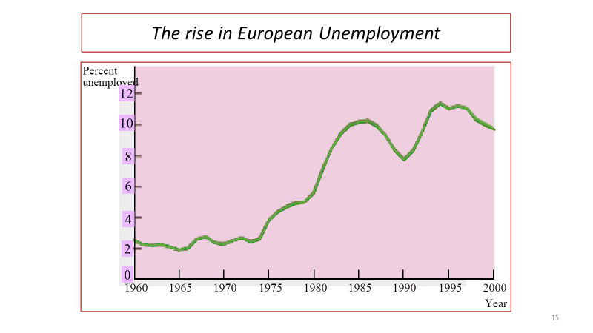
- (10 points): Download data from FRED (https://fred.stlouisfed.org/) on the U.S. inflation rate (CPIAUCSL) and the unemployment rate (UNRATE). Estimate the accelerationist Phillips Curve for the period 1970 to 1995 and the Phillips Curve from 1996 to 2018. Please copy the two charts into the Word documents (and attach a separate EXCEL sheet to show your work).

- (20 points): Draft the monetary policy decision that the U.S. Federal Reserve will release on Sep. 21, 2022. Your statement should look like this: https://www.federalreserve.gov/newsevents/pressreleases/monetary20220727a.htm

