Group Assignment
Group Member: Xiaolan Ma, Qi Zhou, Luoxin Wang, Zhihao Zhang, Hanzhe Zhang, Wanqi Zhang

- No, we do not agree with President Biden’s claim. Firstly, the high inflation rate in 2021, which is 7% and reaches 8.3% in 2022. High inflation rate would cause the prices of goods increase, which lead to the consumption expenditure growing. The promotion of personal consumption expenditure is 82.59%, so that the high inflation rate also contributes to the growth of GDP. Secondly, the economic depression caused by the Covid-19 in 2020. The GDP growth in 2020 is negative 3.5%, it is normal for the GDP to have a high growth rate because demand is strongly rebounding. Thirdly, the incredibly spiking US national debt, the increase in US GDP bases on increasing debt.

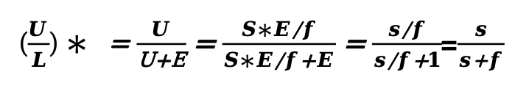

- First of all, we simplify the equation to $\left(\frac{U}{L}\right)* =\frac{1}{1+f/s}$. We can see that the unemployment rate(U/L) is positively related to the job separation rate(s) and negatively related to the job finding rate(f). s and f may both increase between 1975 and 2000, but the difference between s and f has got smaller. Also, f may increase and s may decrease.

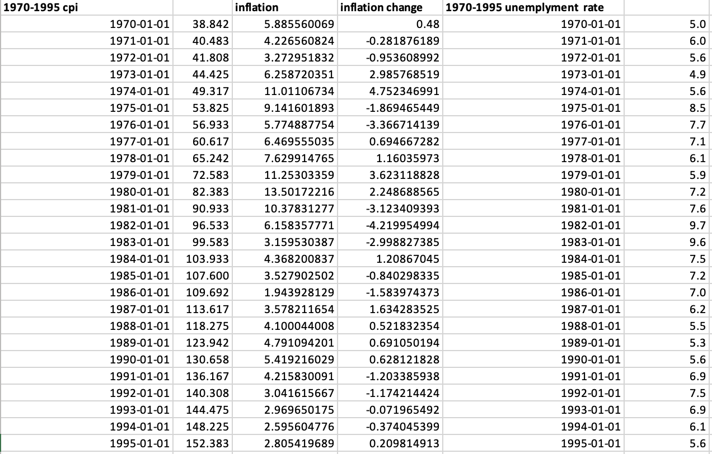

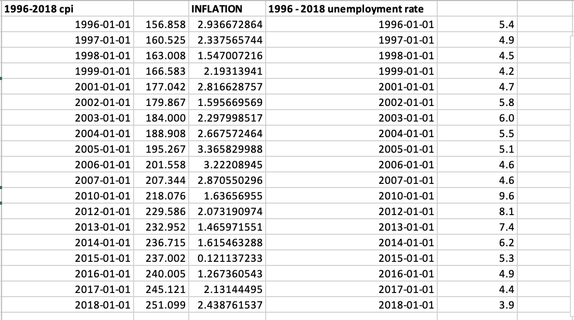

Information received since the Federal Open Market Committee meeting in July indicates that the domestic economy continues to face multiple distress. The unemployment rate has recently stabilized near 3.6% and employment continues to increase. Mortgage rates have been increasing and real estate growth has slowed severely. In addition, consumer spending has fallen short of expectations. Inflation levels are currently at historic highs, and monetary policy measures taken to reduce inflation could lead to lower economic growth and a weaker job market.

China's economy has slowed more than expected due to the new crown epidemic and epidemic prevention measures; in addition, the war in Ukraine has brought more negative spillover effects. Higher food and energy prices and the persistence of supply-demand imbalances led to an upward revision of global inflation forecasts (although lower demand played a mitigating role). The Committee is highly concerned about inflation risks.

To return inflation to its lower percent and to stable a stronger economic recovery,the Committee decided to raise the federal funds rate to 3.25% to deal with the too high inflation.On the other hand,to avoid the lower growth that policy would lead to, the Committee will continue reducing its holdings of Treasury securities and agency debt and agency mortgage-backed securities to inspire consumers to invest.The Committee will regularly review the size and composition of its securities holdings and is prepared to adjust those holdings as appropriate to promote a stronger economic recovery in a context of price stability.

In addition,the Committee will closely monitor incoming information on economic and financial developments in coming months. If the outlook for the labor market becomes weak, the Committee will purchase agency mortgage-backed securities, undertake additional asset purchases, and employ its other policy tools as appropriate until such improvement is achieved in a context of price stability. In determining the size, pace, and composition of its asset purchases, the Committee will, as always, take appropriate account of the likely efficacy and costs of such purchases.

