Group members:
Zhuoran Qiu, Jiawei Wen, Victoria Asiedu, Qiangpeng Wang, Shenghao Wen

- We don't agree that it's all because Biden's economic policies have led to record GDP growth in 2021. We can see from the data that the GDP growth rate in 2020 is -3.4%, as the coronavirus ravages homes and factories, resulting in a large number of job losses. The high GDP in 2021 can only indicate that the economy has begun to recover and is gradually developing under the government's macro-control. In addition, we should not ignore the inflation problem America are currently facing. As we all know, the rate of growth of real GDP equals to the rate of growth of nominal GDP minus the rate of inflation.

- sE=fU
s=f U/E
U+E=L
s/(s+f) = (fU/E)/(fU/E+f)=f(U/E)/f(U/E+1)=U/(U+E)=U/L

- According to natura rate of unemployment = $s/(s+f)$, either increaing of s or decreasing of f, can lead to the increase in umemployment. As long as the ratio of $s/f$ increased, the natura rate of unemployment will increase.

- 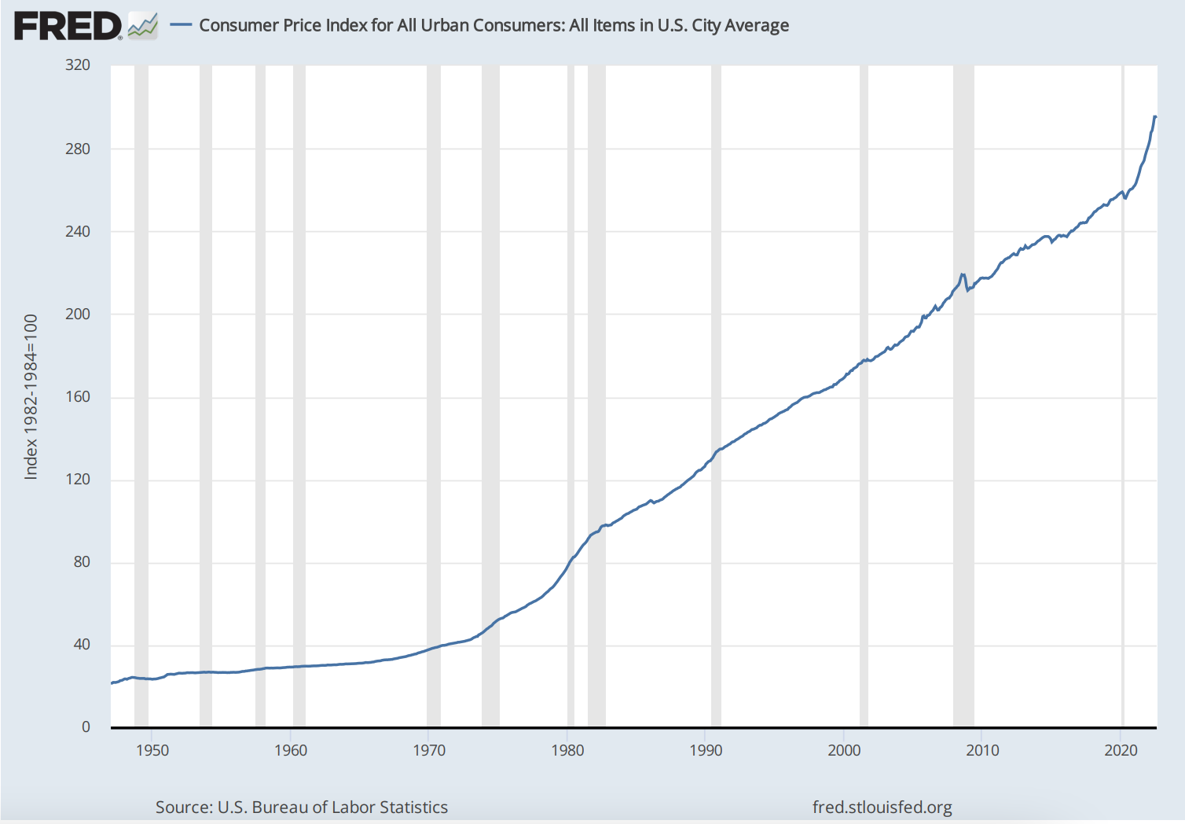
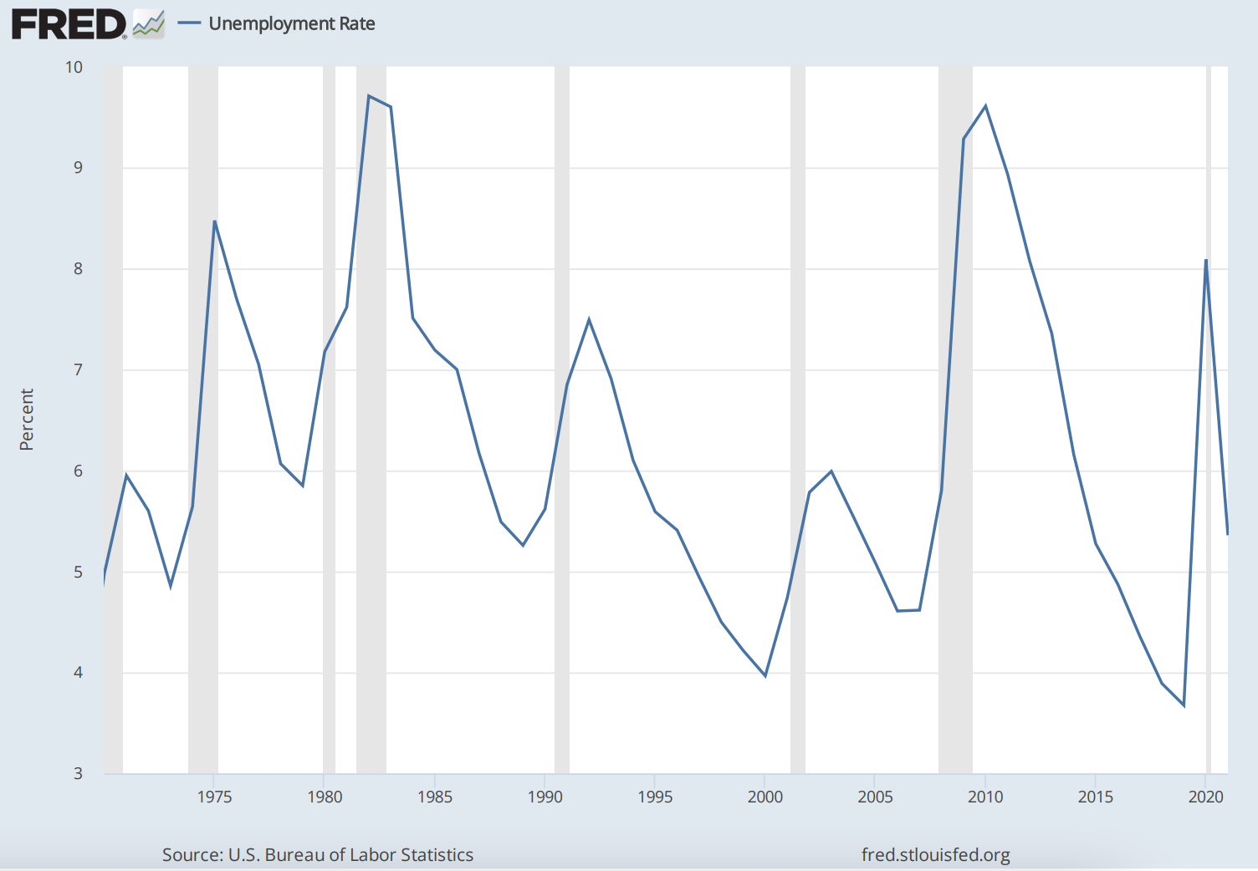
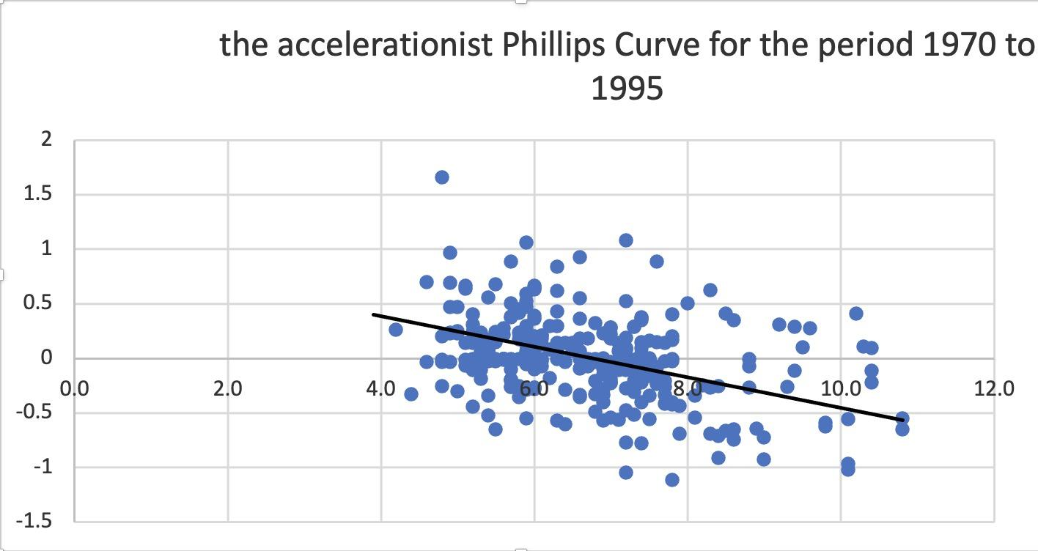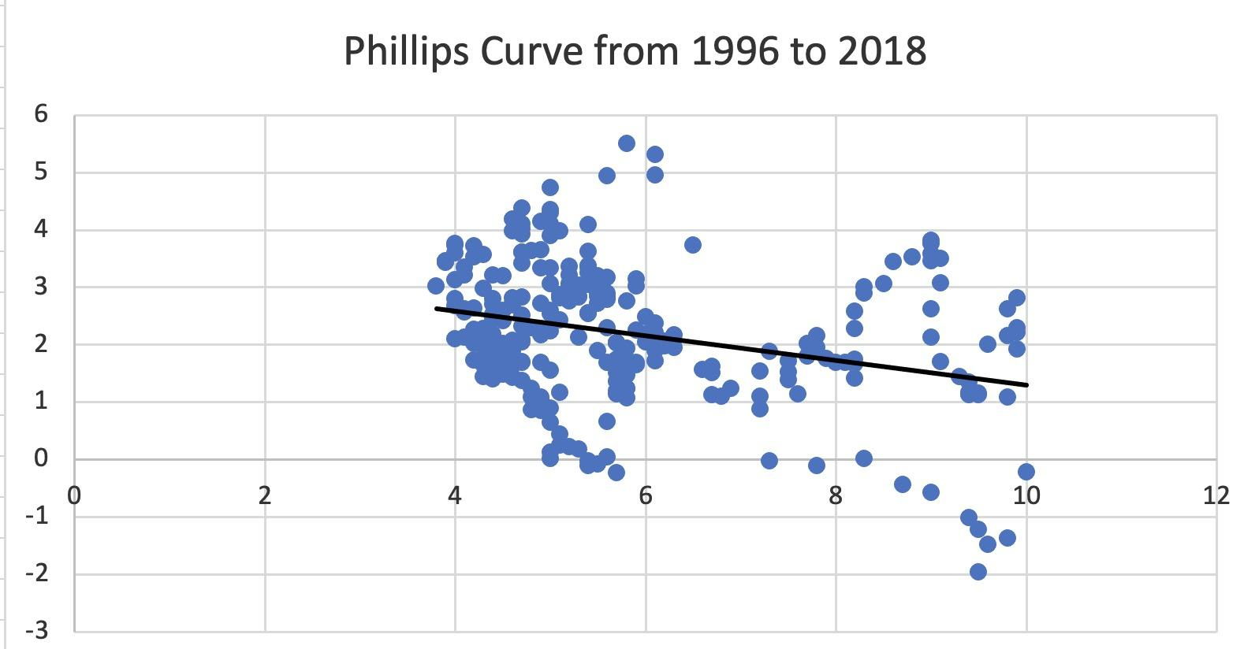

September 21, 2022

Federal Reserve issues FOMC statement
For release at 2:00 p.m. EDT

Recent indicators of spending and production have softened. Nonetheless, job gains have been robust in recent months, and the unemployment rate has remained low. Inflation remains elevated, reflecting supply and demand imbalances related to the pandemic, higher food and energy prices, and broader price pressures.
Russia's war against Ukraine is causing tremendous human and economic hardship. The war and related events are creating additional upward pressure on inflation and are weighing on global economic activity. The Committee is highly attentive to inflation risks.
The Committee seeks to achieve maximum employment and inflation at the rate of 2 percent over the longer run. Currently, Inflation is still on the rise and there are no signs of a slowdown in the near future. In support of these goals, the Committee decided to raise the target range for the federal funds rate to 3 to 3-1/4 percent and anticipates that ongoing increases in the target range will be appropriate. In addition, the Committee will continue reducing its holdings of Treasury securities and agency debt and agency mortgage-backed securities, as described in the Plans for Reducing the Size of the Federal Reserve's Balance Sheet that were issued in May. The Committee is strongly committed to returning inflation to its 2 percent objective.
In assessing the appropriate stance of monetary policy, the Committee will continue to monitor the implications of incoming information for the economic outlook. The Committee would be prepared to adjust the stance of monetary policy as appropriate if risks emerge that could impede the attainment of the Committee's goals. The Committee's assessments will take into account a wide range of information, including readings on public health, labor market conditions, inflation pressures and inflation expectations, and financial and international developments.

