JHU ECON 602
MACROECONOMIC THEORY AND POLICY
(Fall 2022)

Group Assignment 1 (50 points)
Group member: Haoning Liu, Haoyuan Pang, Qianhe Wang, Cheng Gong, Ziming Chen

Due by email (ploungani@imf.org) by 11 am on Tuesday, Sep. 20.
- (5 points): On January 27, 2022, U.S. President Biden said: “The GDP numbers for my first-year show that we are finally building an American economy for the 21st Century, with the fastest economic growth in nearly four decades … And, for the first time in 20 years, our economy grew faster than China’s. This is no accident. My economic strategy is creating good jobs for Americans, rebuilding our manufacturing, and strengthening our supply chains here at home to help make our companies more competitive”. Do you agree with President Biden’s claim that the fast GDP growth in his first year (i.e., in 2021) is due to his economic strategy? Why or why not? https://www.whitehouse.gov/briefing-room/statements-releases/2022/01/27/president-biden-statement-on-first-year-gdp-growth/
HL: I cannot fully agree with President Biden’s claim about the fast GDP growth in his first year. Although the fact is the annual GDP growth rate of US in 2021 is extremely higher than the growth rate in 2020, and the annual growth rate reached its peak after 1984, the growing unemployment rate and inflation rate still shows that US Economy is still under the needs of recovery. But President Biden did finish a good job compared to his predecessor, especially under the condition of COVID-19.

- (5 points): In this week’s class, we will discuss the equation for long-run equilibrium in the labor market: s ⋅E = f ⋅U (assuming that the labor force is fixed). Use this equation to show that the equation for the natural rate of unemployment is $\left(\frac{U}{L}\right)* =\frac{s}{s+f}$.
Labor Force equals to Employed population plus Unemployed population, L = E+U
=> E = L-U
=> At long-run equilibrium in the labor marke, number of labor force locate a job equals job separation, sE = fU.
=> s(L-U) = fU
=> sL – sU = fU
=> s-sU/L = fU/L
=> s = (s+f)U/L
=> U/L = s/(s+f)
=> As U/L is in the long-run equilibrium, there is no cyclical unemployment
=> U/L = (U/L)* is the natural rate of unemployment.

- (10 points): Continuing with the question above, use the equation for the natural rate to explain why European unemployment went up between 1975 and 2000. You should think about what might have happened to s and f that would lead to the increase in unemployment.
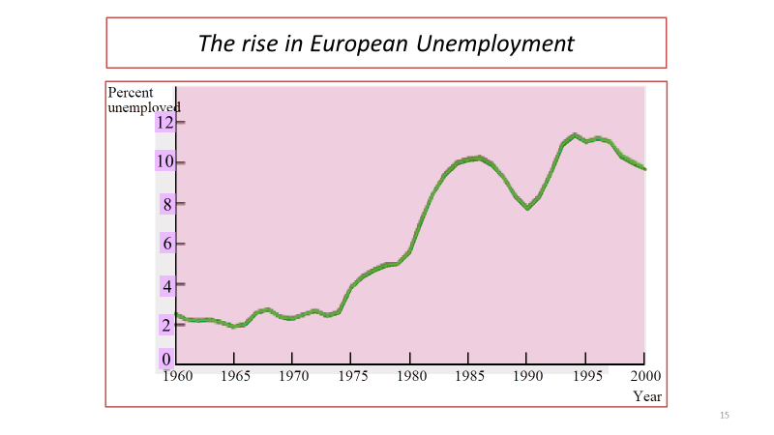
The equation for the natural rate is:
unemployment rate = s / (s + f)
where s is the search intensity and f is the firing cost.
The search intensity (s) grew between 1975 and 2000, which contributed to the rise in unemployment (f), whereas the firing cost (f) reduced during this same time period. Because of this, the number of unemployed persons as well as the unemployment rate increased. The competition for available jobs became more intense as a direct result of the growing number of people looking for work in comparison to the available positions. Because companies were able to lay off employees at a reduced cost, the cost of firing employees went down. This combination resulted in an increase in both the number of unemployed people and the rate of unemployment. It is possible that companies have become more effective at detecting problem employees and terminating their employment, which contributed to the decline in the cost of firing employees. This would result in a reduction in the expense incurred by businesses when terminating employees. Between the years 1975 and 2000, an increase in unemployment can be attributed to both variables.

- (10 points): Download data from FRED (https://fred.stlouisfed.org/) on the U.S. inflation rate (CPIAUCSL) and the unemployment rate (UNRATE). Estimate the accelerationist Phillips Curve for the period 1970 to 1995 and the Phillips Curve from 1996 to 2018. Please copy the two charts into the Word documents (and attach a separate EXCEL sheet to show your work).
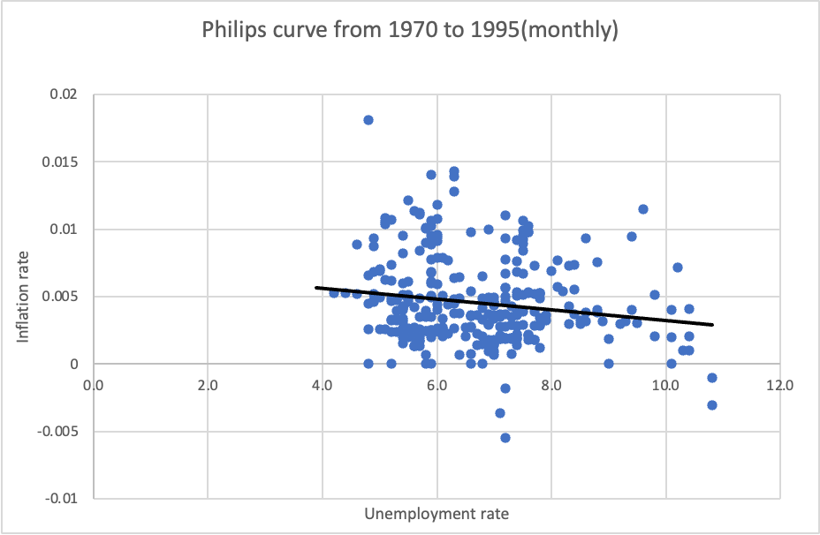
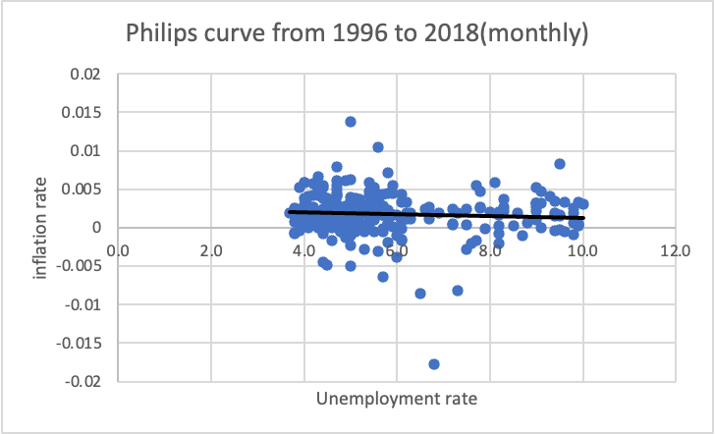

- (20 points): Draft the monetary policy decision that the U.S. Federal Reserve will release on Sep. 21, 2022. Your statement should look like this: https://www.federalreserve.gov/newsevents/pressreleases/monetary20220727a.htm

Monetary policy decision on Sep. 21:

In the past two months, the unemployment rate has increased 0.2 percent. Inflation rate still elevated in the past few months caused by Covid-19. Supply and demand remains imbalanced.
Recently, the war between Russia and Ukraine is still causing some effects on the economy, which explains why the inflation rates remain elevated. The Committee is highly focused on Inflation risks.
The Committee aims to achieve maximum employment and inflation at the rate of 2 percent over the long run and keep raising the federal funds rate to 2-1/4 to 2-1/2 percent. Moreover, the Committee will keep reducing Treasury securities, agency debt and Mortgage-backed securities. The committee will keep working to lower the inflation rate to 2 percent.
The Committee will keep monitoring the economy and be prepared to adjust any inappropriate situations to prevent our economy from any risks. The Committee’s assessments will keep showing more information to the public, including public health, labor market, inflations, and international development.

