JHU ECON 602:
MACROECONOMIC THEORY AND POLICY
(Fall 2022)

Practice Quiz 1
(for Intro and Part A)

- State whether the following statements are True, False or Uncertain. For statements that are False, correct the error or errors. For statements that are Uncertain, explain why that is the case.

- The unemployment rate is the ratio of the unemployed to the labor force.

True.

- The U.S. civilian labor force is about half as large as its population.

True.

- In the United States, the average duration of unemployment—the length of time people spend unemployed—is 2 years.

False. In the United States, the average duration of unemployment—the length of time people spend unemployed—is 2 months.

- A ‘discouraged worker’ is one who is not very good at his or her job and has become discouraged as a result.

False. A discouraged worker is someone without a job who has given up looking for one.

- The employment rate is the ratio of employment to the labor force.

True.

- The Phillips Curve is the negative relationship between the inflation rate and the unemployment rate.

True.

- In the United States, expectations of inflation that became de-anchored during the 1970s and 1980s became re-anchored in the mid-1990s because central banks cut policy interest rates to the zero lower bound.

False. In the United States, expectations of inflation that became de-anchored during the 1970s and 1980s became re-anchored in the mid-1990s because central banks were able to keep inflation rates low and stable.

- The expected present discounted value of a sequence of future payments is the value in the future of this expected sequence of payments.

False. The expected present discounted value of a sequence of future payments is the value today of this expected sequence of payments.

- The higher the nominal interest rate, the higher the value today of a dollar received next year.

False. The higher the nominal interest rate, the lower the value today of a dollar received next year.

- Discount bonds are bonds that promise a single payment at maturity called the face value.

True.

- Coupon bonds are bonds that promise multiple payments before maturity but no payment at maturity.

False. Coupon bonds are bonds that promise multiple payments before maturity and one payment at maturity.

- Equilibrium in financial markets requires that the expected rate of return from holding stocks for one year be the same as the rate of return on one-year bonds plus the equity premium.

True.

- Economists say that since 1960, the United States has become a much more open economy because it allows Chinese students to attend U.S. universities.

False. The U.S. has become more open because exports and imports have increased in relation to GDP.

- Tradable goods are goods that compete with foreign goods in either domestic markets or foreign markets.
True.

- Since a country cannot export more than it produces, the ratio of exports to GDP will always be less than one.

False. Exports may be larger than GDP because exports and imports may include exports and imports of intermediate goods.

- The real exchange rate is the price of domestic goods relative to foreign goods, whereas the nominal exchange rate is the price of the domestic currency in terms of foreign currency.
True.

- A nominal appreciation is an increase in the price of the domestic currency in terms of a foreign currency, while a nominal depreciation is decrease in the price of the foreign currency in terms of the domestic currency.
False. A nominal appreciation is an increase in the price of the domestic currency in terms of a foreign currency, while a nominal depreciation is decrease in the price of the domestic currency in terms of the foreign. currency.
- The U.S. dollar has steadily depreciated against the U.K. pound over the past four decades, reflecting large U.S. current account deficits over this period.
False. The U.S. dollar has appreciated against the U.K. pound over the past four decades.

- According to economists, a real appreciation is when someone really admires your fine qualities.

False. A real appreciation is an increase in the real exchange rate, i.e., an increase in the relative price of domestic goods in terms of foreign goods.
- In September 1993 Brazilian bonds were paying a monthly interest rate of 36.9% while US bonds paid 0.2% monthly; hence Brazilian bonds were a much better investment.

False. They were not a better investment because the Brazilian currency was depreciating rapidly.

- Short answers

- What is the yield curve? What is the normal slope of the yield curve and why?

Relationship between interest rates at different maturities. Normally, upward sloping, due to higher inflation expectations over longer-term.

- On what factors does consumption depend, and why?

Consumptions depends on current income and expected future income. Consumers like to smooth consumption, so they base decisions not only on current income but on wealth.

- On what factors does investment depend, and why?
Investment depends on current profits (relative to user cost) and expected future profits. Like consumers, companies base decisions on current and future profits to avoid excessive dependence of investment decisions on current cash flow.

- What do economists mean by openness in goods, financial and factor markets?

Freedom to choose between domestic and foreign products; domestic and foreign assets; domestic workers and foreign workers.

- What is the interest rate parity condition?

With free flow of capital, domestic and foreign interest rates should be equalized, except for expected depreciation.
- Get the Picture

- Which variable do you think the chart below shows: (i) GDP growth in the United States; (ii) inflation rate in the United States; (iii) The unemployment rate in the United States; (iv) none of the above.
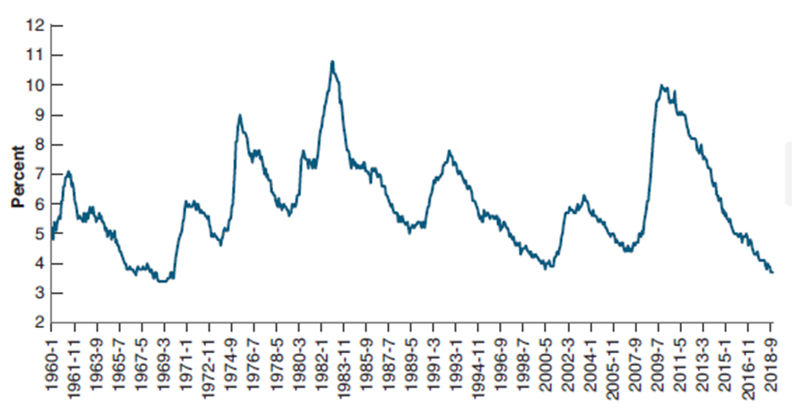

US unemployment rate

- What is this chart called?
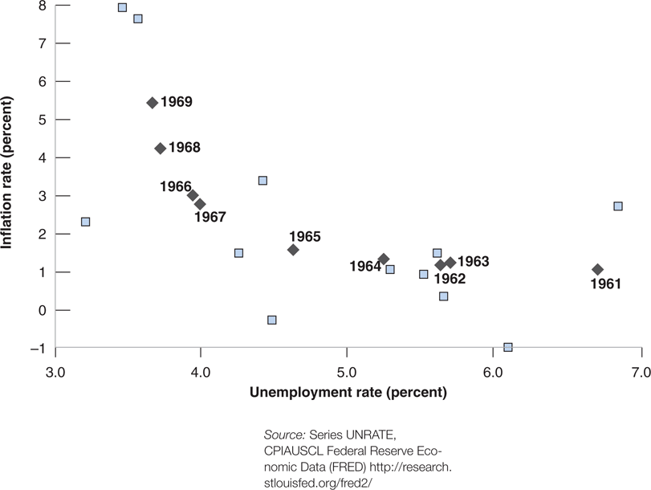
Phillips Curve
- What is this chart called?

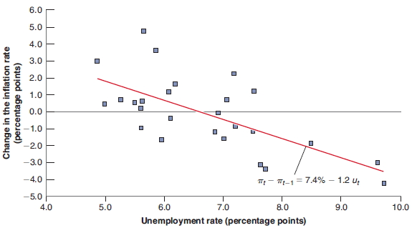
Accelerationist Phillips Curve
- What is this chart called?

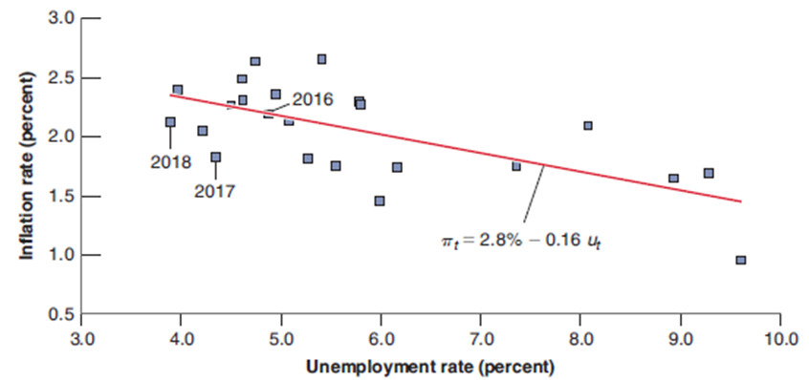
Phillips Curve

- Which variable do you think the chart below shows: (i) GDP growth in the United States; (ii) inflation rate in the United States; (iii) The unemployment rate in the United States; (iv) none of the above.
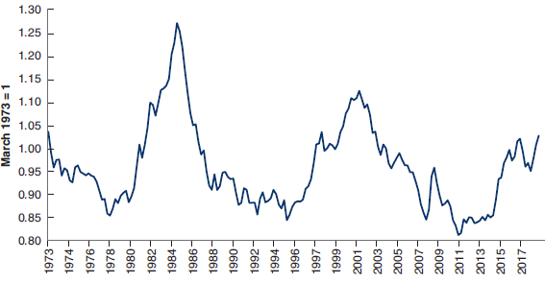
None of the above (it’s the US exchange rate).

