Johns Hopkins University: Applied Economics Program
Macroeconomic Theory and Policy: Syllabus (Fall 2022)
ECON 602: AS.440.602 (52)

Location: Washington DC Center
1717 Mass. Ave., Room 207

Instructor: Prakash Loungani
Email: ploungani@jhu.edu and ploungani@imf.org
Class time: Thursdays, 2-4.40 pm

Cell: 202-459-1306
Office Hours: Wednesdays, 5-6 pm
(and by appointment)

Course Description: (1) Why do incomes differ so much across countries? (2) Why do incomes, even in rich countries, fluctuate from year to year, sometimes falling as during the Great Recession (2008-09) and—though this is not a big mystery—in 2020? This course covers the answers that macroeconomists provide to these two questions. Students will be introduced to the facts about several economies around the globe, to the models that macroeconomists use to try to understand these facts, and to the role that government policies can play in raising incomes over time and in stabilizing year-to-year fluctuations.

Textbook: Olivier Blanchard, Macroeconomics, 8th edition (2021).

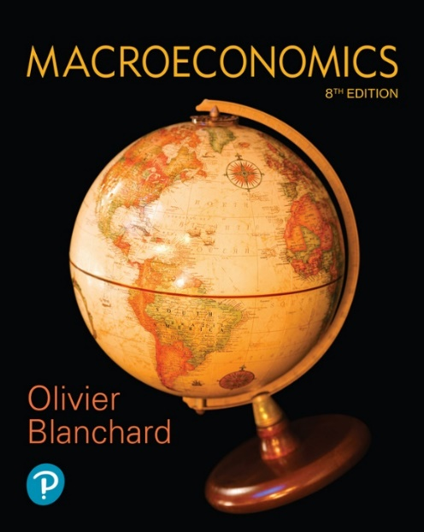

Course Overview:
Part | Dates | Topics | Textbook Chapters
Intro | Sep. 1 | Introduction | 1-4
 | Sep. 8 | Introduction (virtual class)
A | Sep. 15, Sep. 22 | Macroeconomic Fundamentals: Indicators, Inter-relationships, Interventions | 6.1, 6.2, 7-8, 14-15, 17, 21-24
September 29: First Quiz (in class)
B | Oct. 6, Oct. 13 | Macro Models: Short-Run | 5-6, 9, 16, 18-20
October 20: Second Quiz (in class)
C | Oct. 27, Nov. 3 & 10 | Long-Run Growth | 10-13
November 17: Third Quiz (in class)
November 24: Thanksgiving Break (no class)
December 1: Student presentations of individual project
 | Dec. 8 | Review Session
Week of December 12: Final Exam

